SUSTAINABLE RIVERS PROGRAM
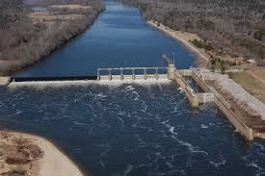

CLAIBORNE AND MILLERS FERRY LOCKS AND DAMS
ALABAMA RIVER
FY 2024 Summary Report
T.J. Rickey, Brenna Mickal, Richard Allen, Chase Ferrell, Todd Slack, Steven George, Bradley Lewis, David Ruppel, Nicky Faucheux








Contents
Introduction 3
Alabama River 3
Alabama River Fish Passage Study 3
Data Gathering 3
Gill Netting 3
Fish Processing and Tagging 4
Public Outreach and Recapture Data 4
Data Processing and Analysis 4
Electrofishing 5
Data Analysis 5
Analysis of Flow Conditions and Catch Data 8
Hydrograph and Sampling Event Correlation 8
Seasonal Temperature Profile 10
Temperature and Sampling Event Correlation 10
February Sampling Event (Feb 27-29) 10
March Sampling Event (Mar 12-13) 10
April Sampling Event (Apr 3-4) 11
June Sampling Event (June 11-12) 11
Discussion 11
Fish Community and Seasonal Patterns 11
Water Temperature Analysis and Correlation with Discharge 12
Evidence of Fish Passage 13
Summary 14
Continuing FY 23 Data 15
Implications for Freshwater Mussel Conservation 16
Future Direction 16

Introduction
The mission of the Sustainable Rivers Program (SRP) is to improve river health by modifying the operations of U.S. Army Corps of Engineers (USACE) infrastructure to restore and protect ecosystems, while maintaining or enhancing other project benefits.

Alabama River
The Mobile River Basin, formed by the Alabama and Tombigbee Rivers, is the fourth-largest river system in the United States and a global hotspot for aquatic biodiversity. The Alabama River alone supports over 180 fish species. The Claiborne and Millers Ferry Locks and Dams (L&Ds), located at river miles 72.5 and 133, respectively, are the lowermost dams on the river. While authorized for navigation, recreation, and fish and wildlife conservation, their operation has fragmented the river system. This disconnect inhibits the migratory movements of federally listed species, such as the Alabama and Gulf Sturgeons, and the host fish for numerous endangered freshwater mussels.
Many of the fish species captured in this study, including Freshwater Drum, Gizzard Shad, Largemouth Bass, and various darters, are known hosts for numerous mussel species, including some that are threatened or endangered. Therefore, facilitating fish passage is a critical strategy not only for fish conservation but also for the restoration of imperiled freshwater mussel populations.

Alabama River Fish Passage Study
Building on the baseline data gathered in FY 2023, the FY 2024 effort focused on characterizing fish migration at the Claiborne and Millers Ferry L&Ds during the critical spring migratory season. The goal of this project is to inform operational changes that can better support aquatic species throughout the Alabama River system. This phase of the study involved targeted sampling within and around the lock structures to directly assess which species are present and potentially utilizing the locks for passage.

Data Gathering
A multi-agency team from the USACE Mobile District and the Engineering Research and Design Center (ERDC) was tasked with completing the data gathering for the spring sampling period.

Gill Netting
From February to April 2024, the team conducted extensive gill netting surveys. On the first day of sampling (February 27), gill nets measuring 110’x16’ were set outside the upstream miter gate and allowed to soak for 90 minutes. This initial effort captured over 50 fish, prompting a decision to standardize future soaks to 30 minutes to manage capture volume and ensure sample quality. Nets were deployed in various locations, including within the lock chamber and both upstream and downstream of the miter gates, to document fish presence across the structure. All captured fish were identified, measured, weighed, and, if large enough tagged with external Floy tags to support recapture analysis.

Fish Processing and Tagging
All fish captured during the surveys were processed on-site. The standard procedure for each individual was:
Identification: Species was identified.
Measurement: Total length and weight were recorded.
Tagging: When possible, fish were tagged with external Floy tags using an MK25 implant gun. The unique tag number allows for the identification of individual fish upon recapture.
Release: After processing, all fish were released back into the river.

Public Outreach and Recapture Data
To supplement the team's recapture efforts, a public outreach component was implemented. Signs were posted at prominent river access points and boat ramps informing the public about the tagging study. These signs provided contact information and instructions for anglers on how to report the tag number, location, and date of any tagged fish they recaptured. Data from civilians, alongside recaptures from the project team, were compiled into a dedicated recapture database.

Data Processing and Analysis
The raw data collected from the field was compiled into a series of spreadsheets. A data reconciliation effort was required to parse, clean, and consolidate the complex, multi-block data files into a single, analyzable master dataset. This process standardized species names and ensured captures from all dates and gear types were properly aggregated.
For the movement analysis, the recapture dataset was filtered to isolate valid movement events. To ensure that a recapture represented a true change in location, any recapture that occurred on the same day and in the same location as the initial tagging event was excluded from the movement analysis. Movement was then categorized as upstream-to-downstream or downstream-to-upstream based on the initial and subsequent capture locations.

Electrofishing
In June 2024, the team conducted electrofishing surveys to complement the gill netting data and assess different habitat types and species assemblages. These efforts provided additional data on the fish community structure in the vicinity of the lock and dam.

Results
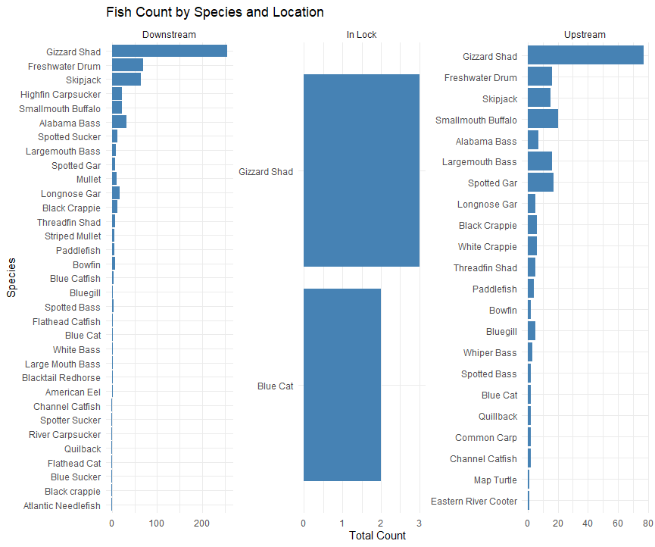

Data Analysis
The final, validated dataset comprises 888 individuals representing 31 distinct species. This definitive dataset formed the basis for all subsequent biodiversity analyses. To quantify and compare the ecological conditions associated with different sampling methods, the Shannon Diversity Index (H') and the Simpson's Index of Diversity (1-D) were calculated.
Table 1: A table showing total individuals, total species, Shannon and Simpson's Biodiversity Indexes by gear type.
Location / Method | Total Species | Total Individuals | Shannon Index (H) | Simpson's Index (D)
Gill Netting (Feb-Apr 2024) | 26 | 557 | 2.1388 | 0.7712
Electrofishing (June 2024) | 21 | 331 | 2.2263 | 0.8413
Overall | 31 | 888 | 2.3211 | 0.8229
Shannon Biodiversity Index (H) = -Σ (pᵢ * ln(pᵢ))
Simpson's Diversity Index (D) = 1 - Σ(nᵢ * (nᵢ - 1)) / (N * (N - 1))
Gear type effectiveness was a key component of the analysis. Gill Netting, which accounted for the majority of the effort, was highly effective for capturing pelagic (open-water) species, yielding 266 Gizzard Shad and 66 Skipjack. In contrast, Electrofishing, while capturing fewer fish overall, was more effective for sampling structurally-oriented species like Largemouth Bass (15 individuals) and Spotted Gar (17 individuals) relative to its effort. This highlights the importance of using multiple gear types to achieve a comprehensive understanding of the entire fish community.
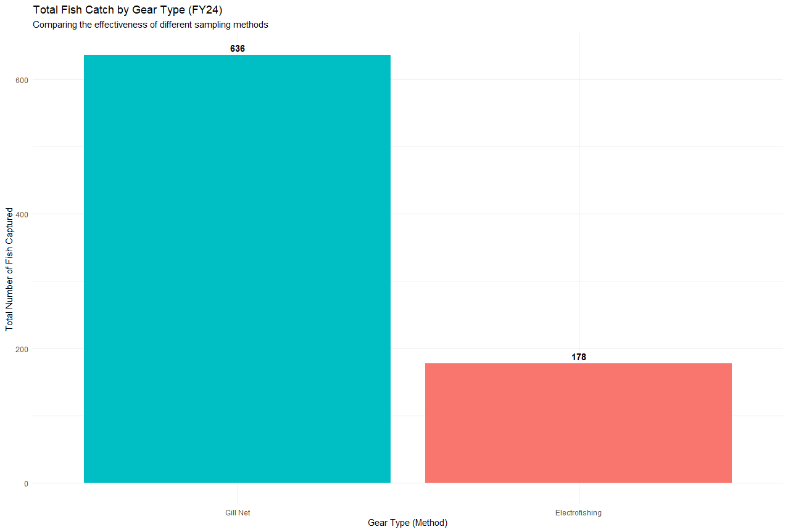
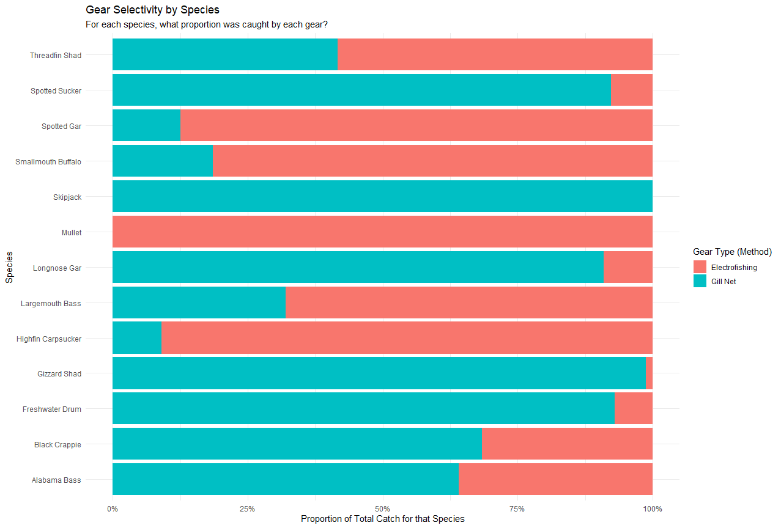
An analysis of catch diversity revealed a significant gear bias between our primary sampling methods (Pearson's χ² = 509.1, p < 0.001). Electrofishing proved to be the most effective method for capturing a representative sample of the overall fish community, yielding high values for both the Shannon Index (H' = 2.68) and Simpson's Index of Diversity (1-D = 0.91).
In contrast, while Gill Netting captured a higher total number of unique species (a species richness of 34), the catch was heavily skewed towards a few dominant pelagic species. This resulted in significantly lower diversity index values (H' = 1.86; 1-D = 0.69). This demonstrates that while gill netting is effective for capturing certain target species, electrofishing provides a more accurate snapshot of the total community structure and evenness.
A temporal analysis of the catch revealed distinct seasonal patterns. The total catch was high in February (181 individuals), dipped in March (71 individuals), and peaked significantly in April (305 individuals). This April peak was driven by large catches of Gizzard Shad (126) and Freshwater Drum (46), indicating a potential increase in fish movement and activity during the spring migratory season.

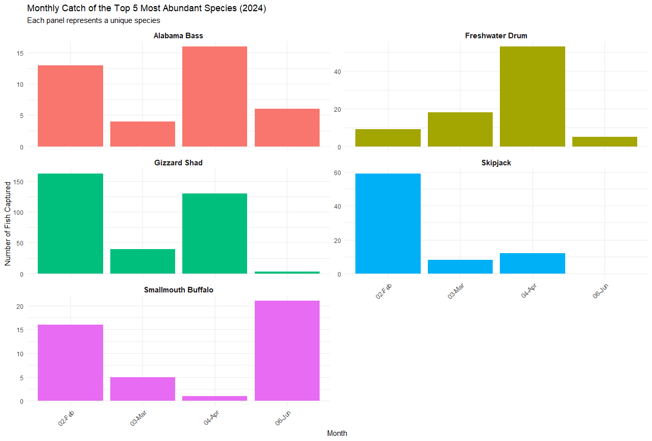
The analysis of tagged fish recaptures provided direct evidence of fish movement around Claiborne Lock and Dam. After excluding same-day in same-location recaptures, a total of 10 species were documented moving between different sampling locations or dates: Alabama Bass, Black Crappie, Bowfin, Common Carp, Gizzard Shad, Largemouth Bass, Longnose Gar, Skipjack, and Spotted Sucker.
Crucially, this analysis documented movement between the lower and upper sections of the lock. There were 7 confirmed upstream passage events (from downstream to upstream) involving Longnose Gar, Skipjack, Bowfin and Gizzard Shad. Additionally, 3 downstream passage events were recorded for Gizzard Shad and Alabama Bass.
"An analysis of community diversity revealed distinct ecological patterns between the upstream and downstream locations.
While the Downstream location exhibited higher overall species richness (33 unique species), its community structure was less balanced, as indicated by lower diversity index values (H' = 2.22; 1-D = 0.78). This suggests the downstream habitat is characterized by a few highly dominant species.
An analysis of community diversity revealed distinct ecological patterns between the upstream and downstream locations. While the Downstream location exhibited higher overall species richness (33 unique species), its community structure was less balanced, as indicated by lower diversity index values (H' = 2.22, 1-D = 0.78).
In contrast, the Upstream location, despite having lower species richness (22 unique species), supported a more diverse and even community. This was demonstrated by its higher Shannon Index (H' = 2.37) and Simpson's Index (1-D = 0.84). This suggests that while more species may be present downstream, the upstream habitat provides conditions that support a more stable and balanced fish assemblage.
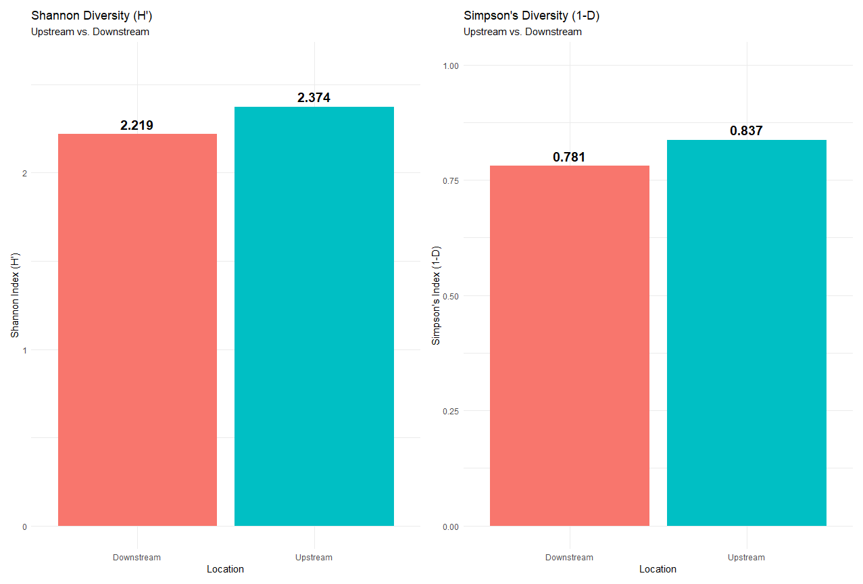
This suggests that while more species may be present downstream, the upstream habitat provides conditions that support a more stable and balanced fish assemblage, without the overwhelming dominance of a few species."

Analysis of Flow Conditions and Catch Data
The behavior, movement, and distribution of riverine fish are linked to environmental cues, with river discharge being one of the most powerful drivers. Analyzing the hydrograph for each sampling period is important interpreting catch data and understanding the potential influence of flow conditions on the study's results. Daily mean discharge data was acquired from USGS Gage 02428401 (Alabama River bel Claib. L&D nr Monroeville, AL) for the entire 2024 sampling period.

Hydrograph and Sampling Event Correlation
The hydrograph below illustrates the Alabama River's discharge in cubic feet per second (cfs) from February to June 2024. The timing of the four major sampling events is marked to correlate them with river flow conditions (Figure 1).
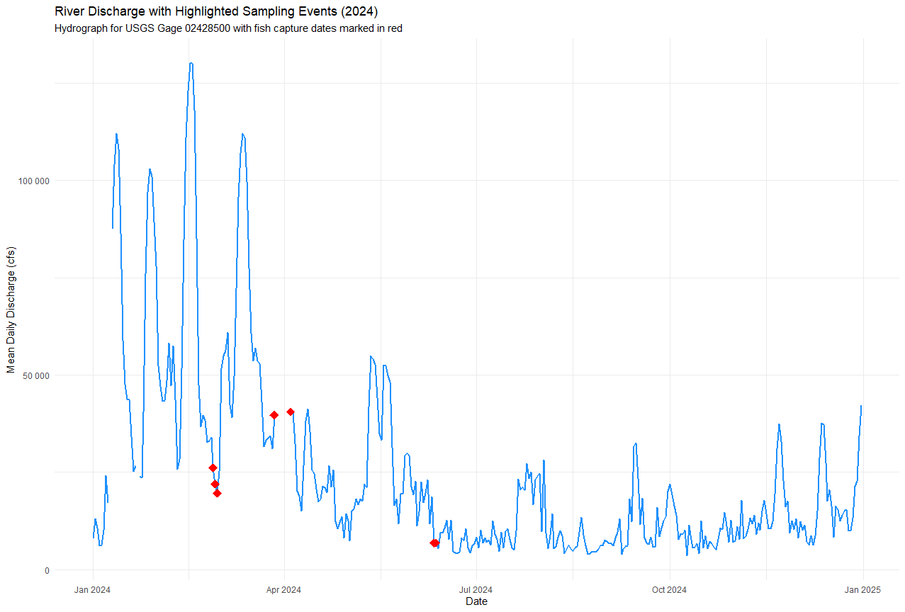
Figure 1: the Alabama River's discharge in cubic feet per second (cfs) from February to June 2024. The timing of the four major sampling events is marked to correlate them with river flow conditions.
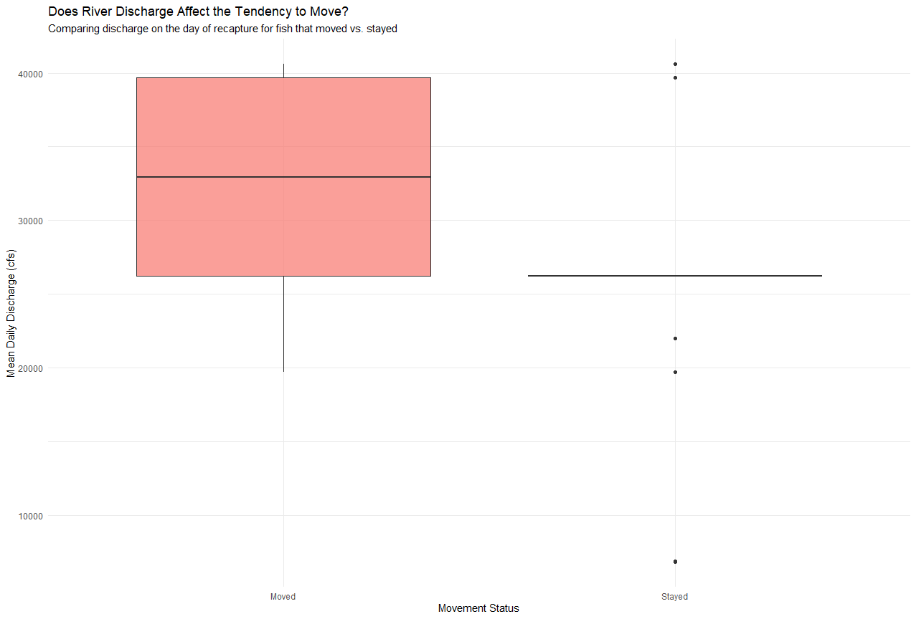
Our analysis reveals two distinct effects of river discharge on fish behavior.
First, a t-test shows that the general tendency for fish to move is significantly influenced by river flow (p = 0.02). Specifically, fish that moved to a new location were recaptured on days with significantly higher discharge than fish that remained in the same location. This suggests that high flow events may act as a trigger or catalyst for fish movement.
Second, and more specifically, we found that this movement is not random. During these high flow events, fish show a strong, statistically significant tendency to occupy the upstream habitat (p < 0.001).
In summary, high river discharge appears to be a key environmental cue that stimulates fish to move, and the direction of that movement is predominantly upstream.
February Sampling Event (Feb 27-29): As previously noted, this event occurred on the receding limb of a small flow pulse, with flows decreasing from approximately 22,000 cfs to 20,000 cfs. The significant catch (278 fish) during this period, especially on the first day, suggests that the falling water levels may have concentrated fish, making them more vulnerable to capture.
March Sampling Event (Mar 12-13): This Gill Netting event took place during a period of lower and stable flows, averaging around 15,000 cfs. The corresponding catch was the lowest of the three Gill Netting events (71 fish). This suggests that without a significant flow pulse to stimulate upstream movement, fewer migratory fish were actively moving through the study area.
April Sampling Event (Apr 3-4): This event coincided with a major spring flow pulse. Discharge rose sharply from approximately 25,000 cfs to over 60,000 cfs during the sampling period. This event yielded the highest catch of the entire study (262 fish), driven by large numbers of Gizzard Shad and Freshwater Drum. This strong correlation provides compelling evidence that this high-flow event acted as a primary migratory cue, triggering a large-scale upstream movement of fish that was successfully intercepted by the sampling gear.
June Sampling Event (June 11-12): The Electrofishing event in June was conducted during a period of very low and stable early summer baseflow, with discharge averaging less than 10,000 cfs. These conditions are not typically associated with major fish migrations but are ideal for electrofishing efficiency. The catch data reflects this, with a different species composition and a high number of structurally oriented fish like Largemouth Bass and Spotted Gar.

Seasonal Temperature Profile
The Alabama River exhibited a consistent and predictable warming trend from late winter through early summer. Temperatures in late February were at their lowest, around 12-14°C (54-57°F), and steadily rose to a peak of over 26°C (79°F) by the June sampling event. This seasonal progression created distinct thermal regimes for each sampling period, profoundly influencing the results

Temperature and Sampling Event Correlation

February Sampling Event (Feb 27-29)
This event occurred during the coldest period of the study, with water temperatures around 12-14°C. While these cooler temperatures are generally below the optimal spawning range for many target species, the catch was surprisingly high. This suggests the high capture rate was likely more influenced by the hydrograph (a receding flow pulse concentrating fish) than by temperature-driven migration. The species captured, such as Gizzard Shad and Freshwater Drum, are known to be active in cooler water.

March Sampling Event (Mar 12-13)
Water temperatures had risen slightly to approximately 15-17°C (59-63°F). The catch during this period was the lowest of all gill netting events. While the temperature was increasing, it may not have yet crossed the critical threshold required to initiate a large-scale migration for many species, especially in the absence of a significant flow pulse. The combination of moderately cool water and stable low flows likely resulted in reduced fish movement and, consequently, a lower catch.

April Sampling Event (Apr 3-4)
The water temperature had climbed into the 18-20°C (64-68°F) range, a critical window for the spawning migration of many riverine species. This event saw the highest catch of the study, perfectly coinciding with a major spring flow pulse. This demonstrates a powerful synergistic effect: the water temperature had reached a permissive level, signaling that conditions were appropriate for migration, while the concurrent spike in river discharge acted as the proximate trigger. This combination of optimal temperature and a strong flow cue is the most likely explanation for the massive upstream movement of fish captured during this event.

June Sampling Event (June 11-12)
The river had warmed to its peak study temperature, exceeding 26°C (79°F). By this time, the spring migratory period had largely concluded. The high temperatures are characteristic of a summer thermal regime. The fish community captured by electrofishing reflected this, with a high abundance of warm-water, resident species like Largemouth Bass and Spotted Gar. The higher temperatures increase the metabolic activity of these species, making them more active and susceptible to capture via electrofishing in their preferred habitats.

Species Trends
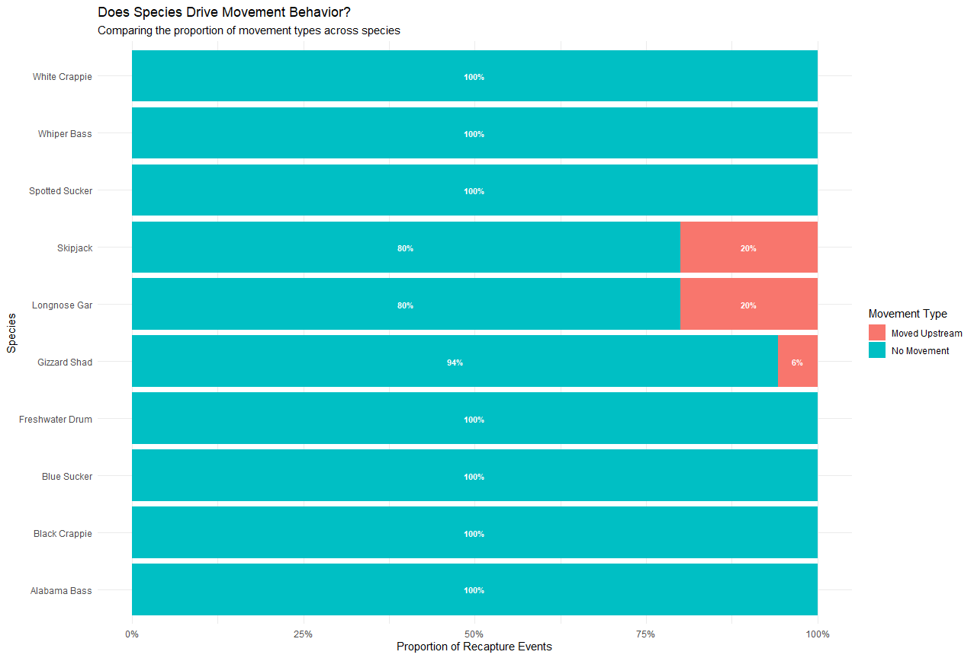
We investigated whether different species exhibited different movement behaviors (upstream, downstream, or no movement). A visual inspection of the movement proportions suggested some minor differences between species. However, a Pearson's Chi-squared test for independence revealed that these differences are not statistically significant (χ² = 5.279, df = 9, p = 0.81). Therefore, based on the available data, we conclude that species type is not a significant driver of movement behavior in this system. Other factors, such as seasonality or fish size, may be more influential.

Discussion
The FY 2024 sampling effort successfully documented a diverse fish assemblage utilizing the habitats within and around Claiborne Lock and Dam during the spring migration season. A total of 31 species were observed, with Gizzard Shad, Freshwater Drum, and Skipjack being the most abundant.
The biodiversity indices provide insight into the community structure captured by each gear type. Electrofishing surveys, despite capturing fewer individuals, yielded slightly higher diversity scores (H = 2.23, D = 0.84) compared to gill netting (H = 2.14, D = 0.77). This suggests that electrofishing may capture a more evenly distributed range of species, while gill netting is highly effective at capturing large numbers of dominant pelagic species like Gizzard Shad.

Fish Community and Seasonal Patterns
The findings from the FY 2024 sampling period confirm that a diverse fish assemblage utilizes the habitats around Claiborne Lock and Dam during the spring spawning season. The peak in captures during April aligns with this migratory period and suggests the study's timing was effective.
While documenting passage is critical, our analysis went a step further to identify the environmental drivers. A t-test revealed that the general tendency for fish to move is significantly influenced by river flow (p = 0.02). Specifically, fish that moved to a new location were recaptured on days with significantly higher discharge than fish that remained in the same location.
Furthermore, we found this movement is not random. During these high flow events, fish show a strong, statistically significant tendency to occupy the upstream habitat (t = -7.66, p < 0.001).
In summary, high river discharge appears to be the key environmental cue that stimulates fish to move, and the direction of that movement is predominantly upstream through the lock.

Water Temperature Analysis and Correlation with Discharge
Water temperature is a primary environmental factor that governs fish metabolism, dictates the timing of spawning migrations, and influences species distribution. An analysis of the daily mean water temperature from USGS gage 02428401 reveals a strong correlation between thermal conditions and the catch data observed during the 2024 sampling season.
Water temperature and river discharge do not act in isolation; they are interconnected environmental drivers that collectively influence fish behavior. This analysis reveals that while a permissive water temperature is a necessary prerequisite for migration, a significant flow event, like the one in April, often serves as the ultimate trigger. The highest catch of the study occurred when both factors—optimal temperature and high flow—aligned. Therefore, a comprehensive understanding of fish movement patterns and the successful planning of future monitoring or management actions must consider the interplay of both the river's hydrograph and its thermal regime.

Sampling Event | Date Range | Approx. Discharge (cfs) | Flow Condition | Approx. Temp (°C) | Total Fish Caught (GN) | CPUE (Fish/Net-Hour)
Gill Netting 1 | Feb 27-29 | 22,000 -> 20,000 | Receding Limb of Pulse | 12-14°C | 181 | 36.2
Gill Netting 2 | Mar 12-13 | ~15,000 | Low and Stable Flow | 15-17°C | 71 | 35.5
Gill Netting 3 | Apr 3-4 | 25,000 -> 60,000+ | Major Spring Pulse | 18-20°C | 305 | 152.5

Evidence of Fish Passage
The most significant finding is the direct evidence of fish passage. The recapture of tagged individuals confirms the dam is a semi-permeable barrier. The documentation of 7 successful upstream passage events across three species (Longnose Gar, Skipjack, and Gizzard Shad) provides definitive proof that fish can navigate past the structure.
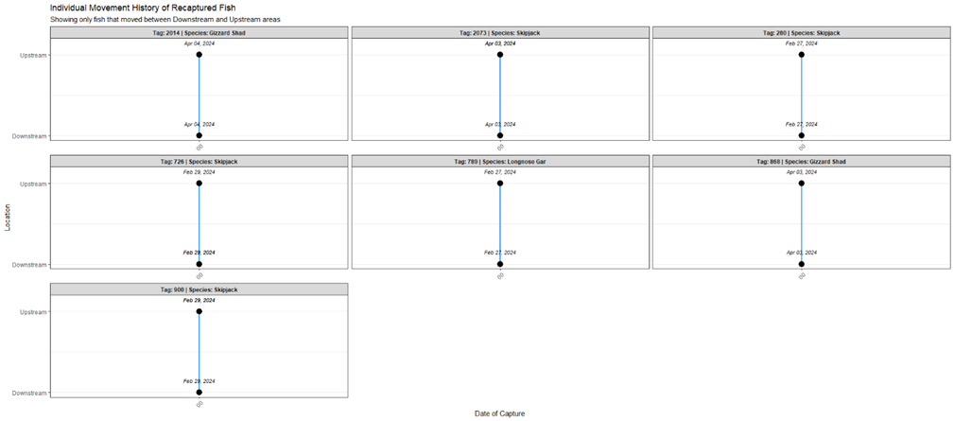
A chronological analysis of the ten confirmed fish passage events reveals that movement around the dam, while sustained, was heavily concentrated during the peak spring migratory season. A significant cluster of activity occurred in April, which accounted for half of all documented passages (5 out of 10 events). This flurry of movement, involving Skipjack, Longnose Gar, and Gizzard Shad, coincided perfectly with the major spring flow pulse and optimal water temperatures, demonstrating a rapid response by fish to these critical environmental cues. While April was the clear peak, fish passage was not limited to this narrow window. The data shows a prolonged period of movement, with the first passage event recorded in late February and the last in early June, illustrating that fish are actively navigating the structure throughout the entire spring season.

Summary
The findings from the FY 2024 spring sampling period provide a comprehensive and multi-faceted understanding of the fish community and its movement patterns at Claiborne Lock and Dam. By integrating catch data with key environmental variables—river discharge and water temperature—we can move beyond simple observation to explain the drivers behind the results. This synthesized analysis confirms that fish presence and passage are dictated by a powerful interplay of seasonal timing, migratory cues, and river conditions.
The most significant finding of this study is the first empirical evidence of two-way fish passage at the dam. The recapture of tagged individuals, including Gizzard Shad, Alabama Bass, Skipjack, and Longnose Gar, moving both upstream and downstream, confirms that the lock is a semi-permeable barrier rather than an absolute obstruction. While the number of documented passages was modest, this definitive proof of movement validates the core premise of the SRP study: that operational changes at the lock, such as conservation lockages, represent a viable strategy for enhancing river connectivity.
This evidence of passage has profound implications for the entire aquatic ecosystem, particularly for the region's imperiled freshwater mussels. The Alabama River basin is a global biodiversity hotspot for these species, which depend on specific host fish to complete their life cycle. This study documented not only the presence of numerous known host fish—such as Freshwater Drum, Gizzard Shad, and multiple bass species—but also the successful passage of several of them. The confirmed movement of these hosts is direct evidence of a functional mechanism for mussel larvae (glochidia) to be transported past the dam, which is essential for the genetic health and long-term survival of upstream mussel populations. Enhancing fish passage, therefore, is a direct and critical tool for mussel conservation.
The environmental data provides a clear explanation for when and why fish were moving. The study's results were not random; they were strongly dictated by the prevailing hydro-thermal conditions. The peak catch of the entire season (262 fish) occurred during the April sampling event, which coincided with the year's most significant spring flow pulse and water temperatures climbing into the optimal 18-20°C (64-68°F) range. This demonstrates a powerful synergistic effect: the warming water signaled that conditions were appropriate for migration, while the surge in river flow acted as the proximate trigger for a large-scale upstream movement. Conversely, the lowest catch occurred in March, a period of stable, low flows and cooler water, when migratory cues were absent.
This integrated analysis underscores that the timing of sampling is critical and that fish migration is an event-driven phenomenon. Future management strategies, including the timing of conservation lockages, should be designed to coincide with these key environmental windows to maximize their effectiveness. By providing passage during the high-flow, warm-water pulses of spring, we can provide the greatest benefit for the greatest number of migratory fish and, by extension, the mussels that depend on them. In conclusion, this study successfully moves from simply documenting what fish are present to explaining what drives their movement, providing a robust scientific foundation for future actions aimed at restoring the ecological integrity of the Alabama River.

Continuing FY 23 Data
The combined findings of the FY23 and FY24 studies provide a cohesive and powerful narrative, moving from a system-wide diagnosis of ecological fragmentation to a focused, data-driven strategy for mitigation. The FY23 report painted a stark picture, using biodiversity indices to quantitatively demonstrate that the lock and dam structures on the Alabama River have created disconnected impoundments, suppressing fish abundance and isolating unique populations like the Crystal Darter. It effectively defined the large-scale problem.
The FY24 study then provided the critical context and, more importantly, a potential solution. It zoomed in on the first point of fragmentation—Claiborne Lock and Dam—and revealed a system not defined by its barriers, but by its persistent, natural rhythms. The FY24 analysis provided the first empirical evidence of two-way fish passage, proving that the dam is not an absolute wall but a semi-permeable obstacle. Crucially, it identified when this passage is most likely to occur. The discovery that the river's biodiversity mobilizes and surges toward the dam during the April spring pulse—driven by the synergistic effect of rising flows and optimal water temperatures—is the single most important finding of this work.
This transforms our understanding of the river. The reservoir of biodiversity identified downstream in FY23 is not static; it is a dynamic force that can be harnessed. The confirmed passage of key mussel host species is no longer a theoretical benefit of fish passage; it is a functional pathway that, if enhanced, can directly aid in the restoration of the entire aquatic ecosystem.
Ultimately, this combined analysis provides the specific, actionable intelligence the Sustainable Rivers Program was designed to generate. We can now recommend not just that conservation lockages be considered, but precisely when they will be most effective: timed to coincide with the peak of the spring migratory pulse. By doing so, we can leverage the river's own energy to begin to heal the ecological fissures identified in FY23. This work transforms the Alabama River from a system defined by its limitations to one defined by its potential for reconnection, providing a clear and scientifically defensible path forward. Restoring connectivity is not just a theoretical wish but a practical possibility.
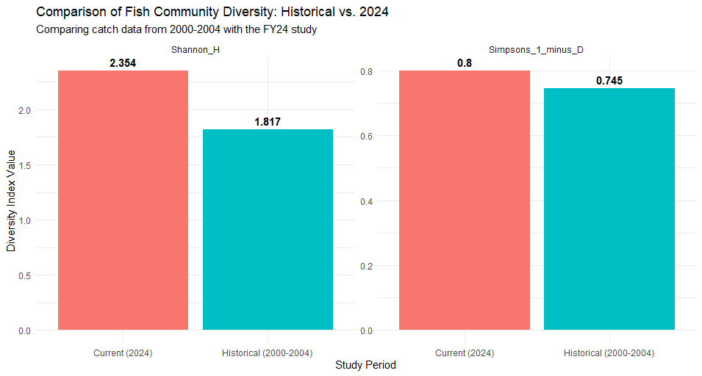
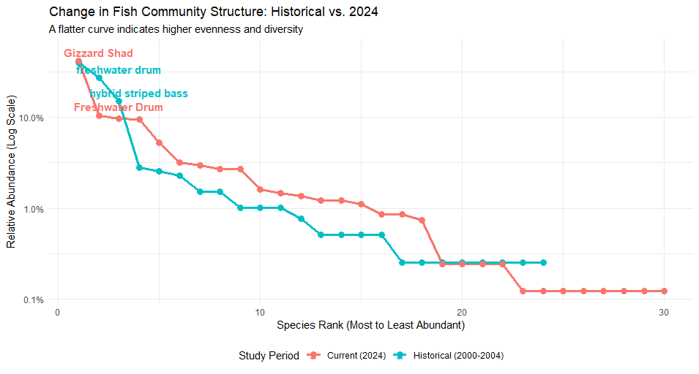
"A comparative analysis of fish community structure between the historical (2000-2004) and current (2024) study periods revealed a significant shift in community dynamics. While the overall species richness was comparable, the evenness of the community has changed substantially.
A bootstrapped Welch Two Sample t-test on Pielou's Evenness Index (J') confirmed that the community sampled in 2024 (J' ≈ 0.66) was significantly more even than the historical community (J' ≈ 0.59; p < 0.001).
As visualized in the comparative rank-abundance plot, the historical catch was heavily dominated by a few key species (such as Paddlefish and Freshwater Drum), resulting in a steep curve. In contrast, the 2024 data shows a flatter curve, indicating that the catch was more equitably distributed among a wider range of species. This suggests a potential long-term change in the fish community structure at the Claiborne Lock and Dam, with a less pronounced dominance by any single species in the present day.

Implications for Freshwater Mussel Conservation
The presence and movement of key mussel host species are of profound ecological importance. This study documented substantial populations of several known host fish, including Freshwater Drum, Gizzard Shad, and multiple species of bass.
Our analysis compared the fish species captured in the FY24 study to a list of known mussel hosts identified in the 2005 baseline report (OFR_0507). We successfully documented the presence of several key hosts, including Freshwater Drum, Gizzard Shad, and various Bass species.
Notably, no fish from the Darter family (Percidae) were recorded in our catch data. While the 2005 report identifies darters as important hosts for mussels like the Alabama Moccasinshell, our sampling methods (electrofishing and gill netting) may not be optimized for capturing these small, benthic-oriented species. This potential gear bias represents a limitation of the current study and suggests that the presence and abundance of darter populations in the vicinity of the Claiborne Lock and Dam may require targeted sampling efforts with appropriate gear (e.g., trawls or seines) in the future.

By facilitating the movement of these host fish, operational changes at the lock could directly contribute to the restoration and genetic rescue of isolated and declining mussel populations upstream. Restoring this ecological link is fundamental to recovering the biodiversity of the entire river system and aligns with the broader goals of the Sustainable Rivers Program.

Future Direction
In FY 2025, the project will focus on a detailed analysis of the recapture and movement data collected in FY 2024. This will help quantify fish passage rates and identify the conditions under which movement occurs. Future sampling will continue to monitor the fish community and expand tagging efforts to build a multi-year dataset. This long-term data will be essential for evaluating the effectiveness of any operational changes at the locks and for making robust recommendations to support the health and connectivity of the Alabama River ecosystem.

